**User Manual**

Step 1. Install jdk for windows or mac.

Step 2. Install Netbeans IDE on your laptop/pc.

Step 3.Open File and click on open project.

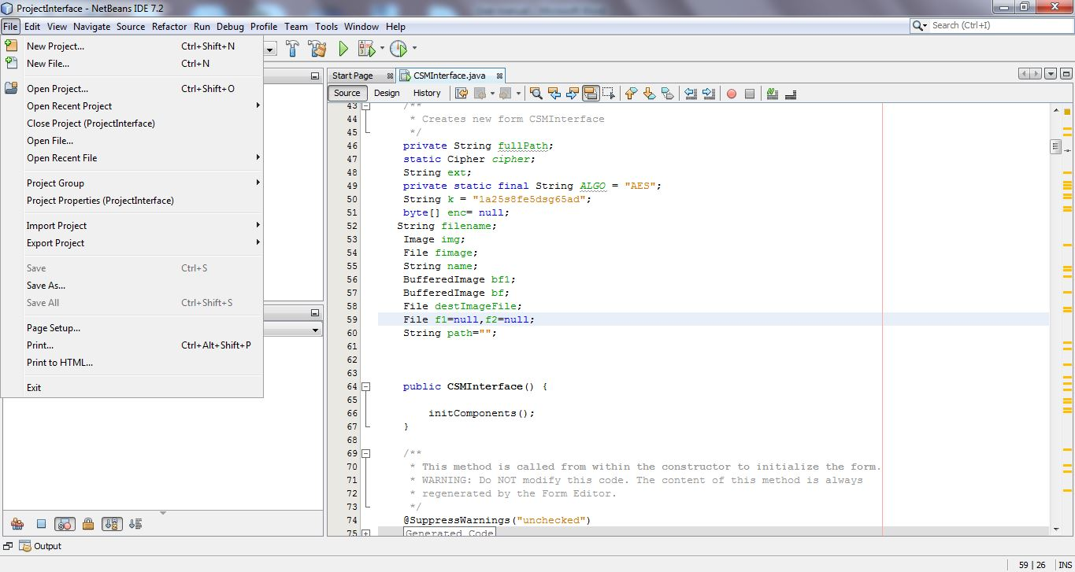

Step 4.Select the project folder name ProjectInterface in the cd as shown.

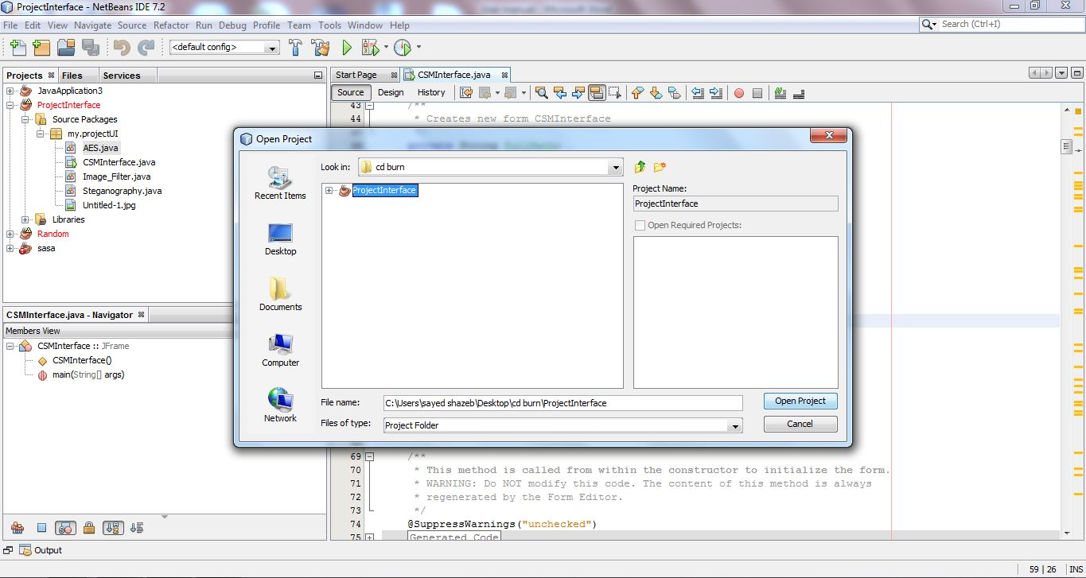

Step 5.Now you can see the ProjectInterface in you project section on Netbeans IDE.

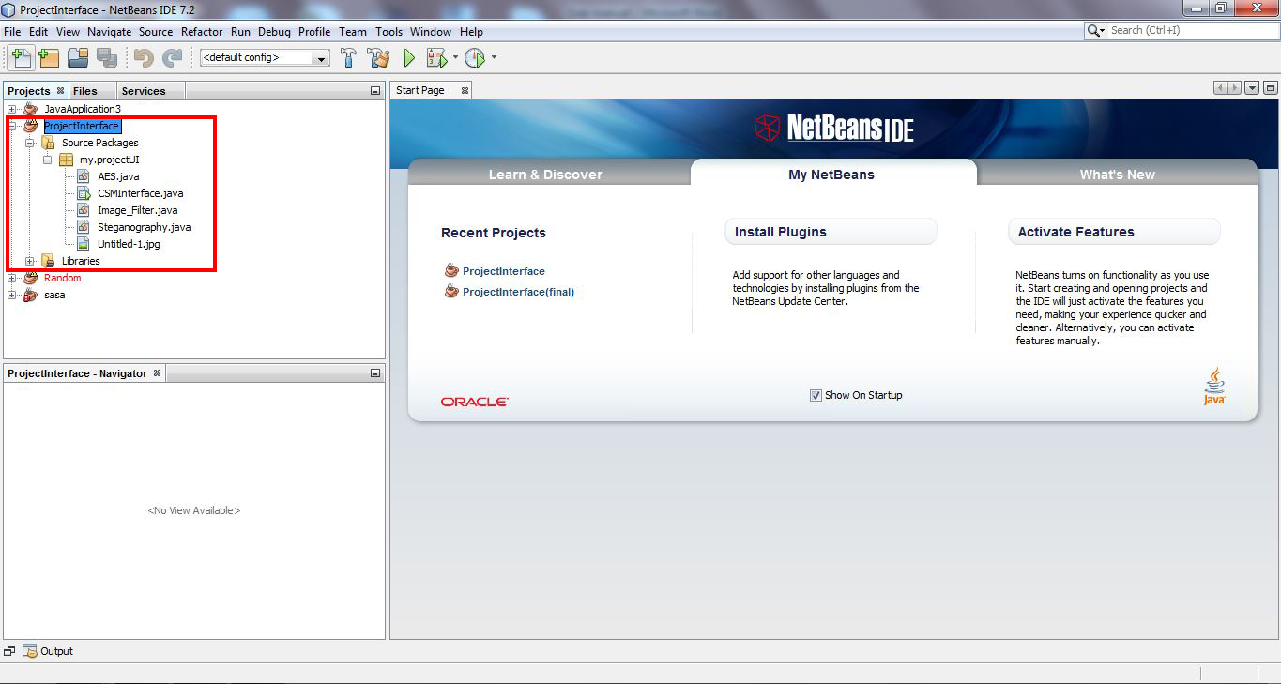

Step 6. Open CSMInterface.java class by double clicking to CSMInterface.java which opens a new tab on main window of Netbeans IDE.

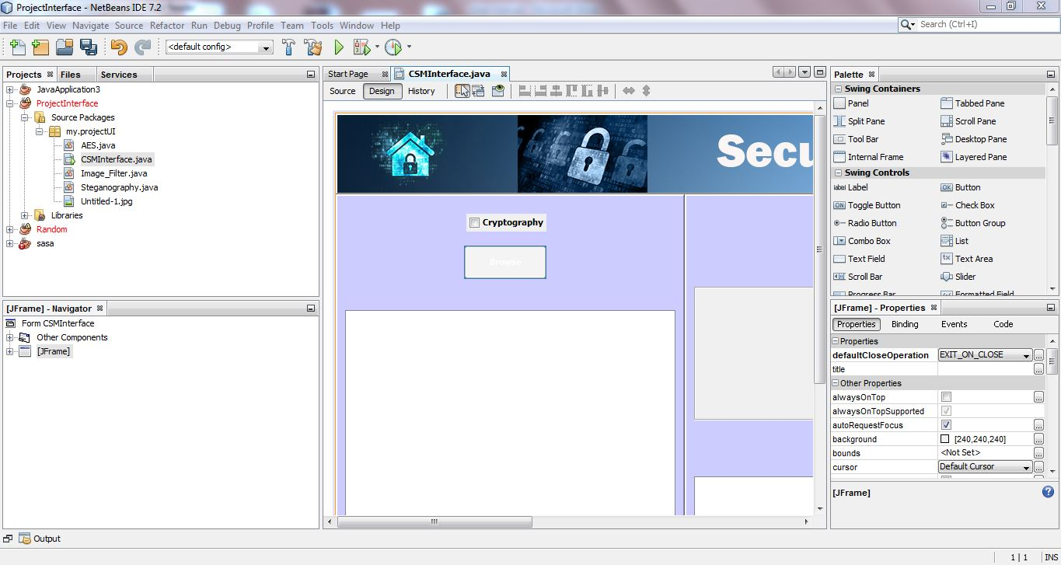

Step 7.Now click on red highlighted green arrow to run the project.

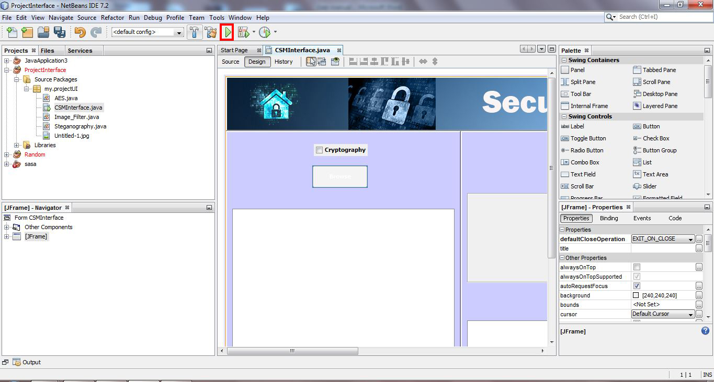

Step 8.Users can also open the System Security.jar by double clicking the file to use the application.

